800 - 900 Series

From 3 to 45 tm class. The articulated line includes a wide range of cranes designed for the installation on a small to big vehicle. With a wide range of accessories and optional devices, each model can be optimized to the application requested by the user. Compact High capacity Perfect combination of cost and performance

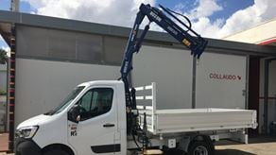

**803.5N**

Max. Lifting capacity (kg)

860

Lifting Moment Class (tm)

3

Max. Extension reach (m)

7.4

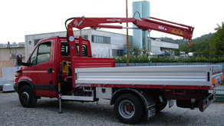

**804**

Max. Lifting capacity (kg)

995

Lifting Moment Class (tm)

3

Max. Extension reach (m)

9.31

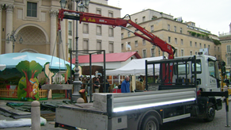

**805**

Max. Lifting capacity (kg)

1930

Lifting Moment Class (tm)

4

Max. Extension reach (m)

9.25

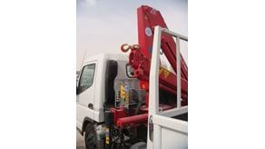

**806N**

Max. Lifting capacity (kg)

2630

Lifting Moment Class (tm)

6

Max. Extension reach (m)

10.4

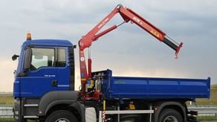

**807N**

Max. Lifting capacity (kg)

1820

Lifting Moment Class (tm)

7

Max. Extension reach (m)

12.2

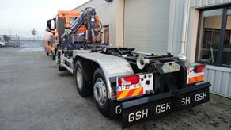

**808N**

Max. Lifting capacity (kg)

2000

Lifting Moment Class (tm)

7

Max. Extension reach (m)

13.7

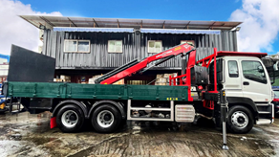

**809NG**

Max. Lifting capacity (kg)

2130

Lifting Moment Class (tm)

9

Max. Extension reach (m)

11.21

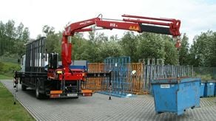

**812**

Max. Lifting capacity (kg)

2730

Lifting Moment Class (tm)

11

Max. Extension reach (m)

14.31



**817**

Max. Lifting capacity (kg)

3620

Lifting Moment Class (tm)

16

Max. Extension reach (m)

16.2